Lab 3: Pushgateway End-to-End
Why Pushgateway?
Cron Job runs for 5 seconds.
Prometheus scrape interval = 15 seconds.
How will Prometheus collect metrics?
Answer:
Pushgateway

Architecture
Backup Script
↓
Pushgateway
↓
Prometheus
↓
Grafana

Step 1: Run Pushgateway
Docker:
docker run -d \
--name pushgateway \
-p 9091:9091 \
prom/pushgateway
Verify:
http://SERVER-IP:9091

Step 2: Configure Prometheus
cd prometheus-2.48.0.linux-amd64
Edit:
vi prometheus.yml
Add:
- job_name: "pushgateway"
static_configs:
- targets:
- localhost:9091
Restart:
pkill prometheus
./prometheus
Verify:
Status → Targets
Should show:
pushgateway UP
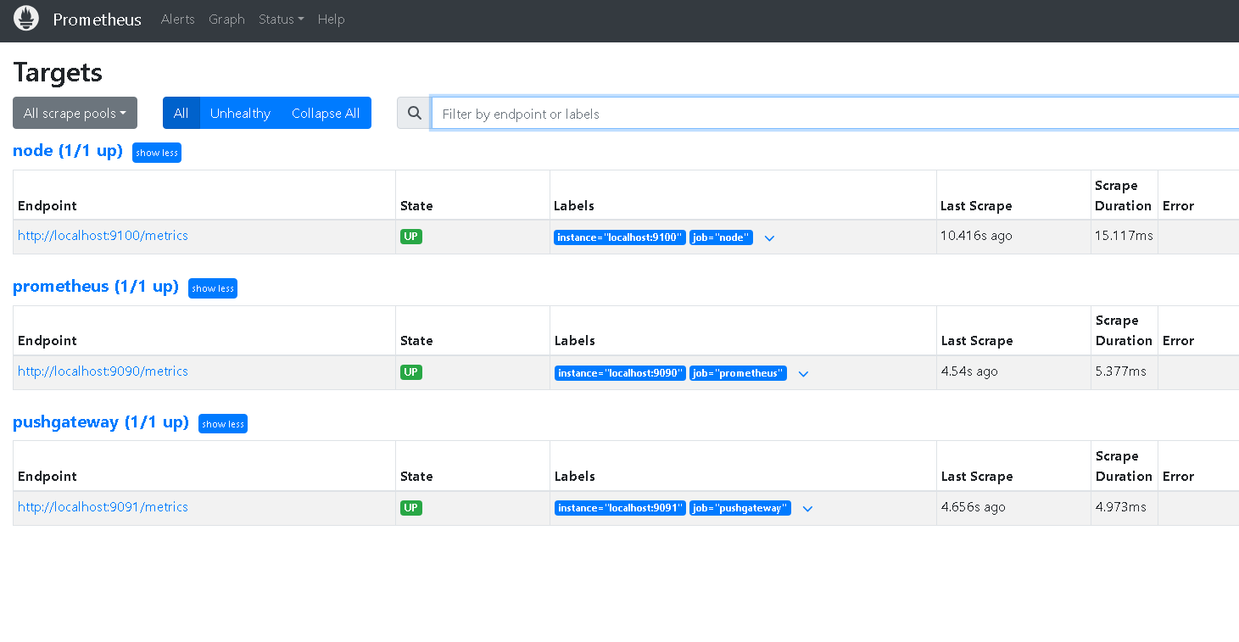

Step 3: Push Custom Metric
Push success metric:
echo "backup_success 1" \
| curl --data-binary @- \
http://localhost:9091/metrics/job/backup

Step 4: Verify
Open:
http://localhost:9091
You will see:
backup_success 1
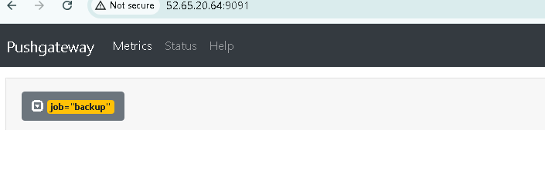

Step 5: Query in Prometheus
backup_success
Output:
1

Step 6: Push Failure
echo "backup_success 0" \
| curl --data-binary @- \
http://localhost:9091/metrics/job/backup
Query:
backup_success
Output:
0

Step 7: Create Alert
groups:
- name: backup-alerts
rules:
- alert: BackupFailed
expr: backup_success == 0
for: 10s
labels:
severity: critical
annotations:
summary: Backup Failed
description: Daily backup failed
Restart Prometheus.

Step 8: Verify Alert
Push:
echo "backup_success 0" \
| curl --data-binary @- \
http://localhost:9091/metrics/job/backup
After 10 seconds:
BackupFailed
FIRING

Final Demo Flow
Cron Job Failed
↓
Pushgateway
↓
Prometheus
↓
Alert Rule
↓
Alertmanager
↓
Slack Notification

